Extranet Android App

Installation Manual

Feb 2020

Objective: To document steps for installing Extranet Android App on Phone devices.

System Requirements:

Minimum Android OS Version Oreo 8.0

Phone Device should have
- Internet Capability (WiFi and/or Phone Data Service)
- GPS Capability
- Bluetooth Capability
- Camera for Barcode Scan Capability

Downloading Build Files to Laptop / Desktop:

- Using the link provided, download the below apk build files to laptop / desktop
- Home apk build file
- Extranet Android App apk build file

Moving Build Files to Phone Device:

- Use USB cable to connect the phone to laptop/desktop. The windows explorer should show the phone device as new drive (refer image below).
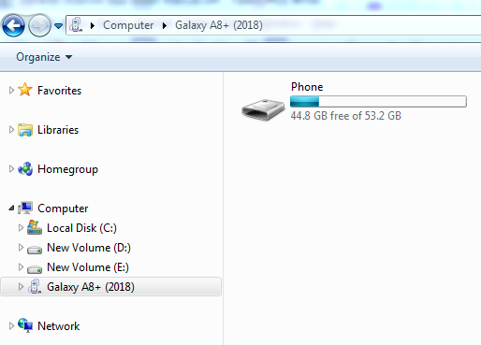
- Create new Extranet folder:
Open the phone device, right click and select New Folder. Name the new folder as Extranet
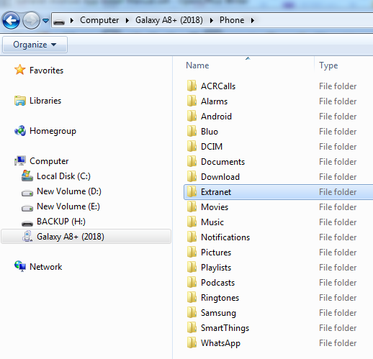

- Copy and Paste downloaded build apk files into the Extranet folder on the phone device.
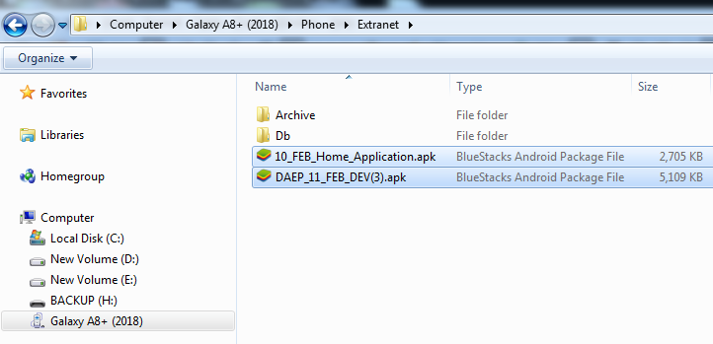
Installing Home App on Phone Device:

- On phone device navigate to Extranet Folder using Samsung > My Files > Internal Storage > Extranet (this path may vary depending on Phone Device Android OS version)
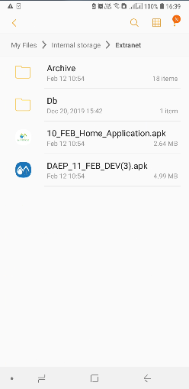

- Tap Click on Home App build apk file to start the installation process.
- Click on Install button.
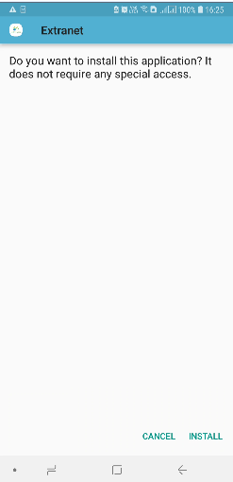
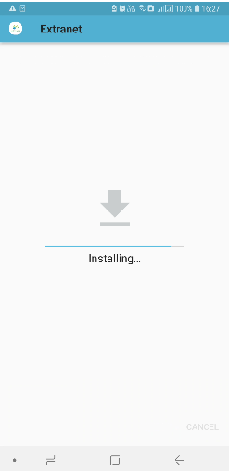
- Click on Done button.
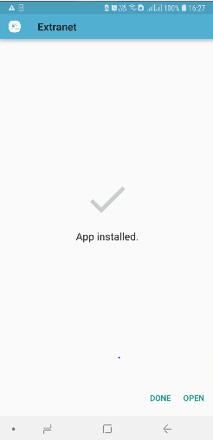
Installing DAEP App on Phone Device:

- On phone device navigate to Extranet Folder using Samsung > My Files > Internal Storage > Extranet (this path may vary depending on Phone Device Android OS version)
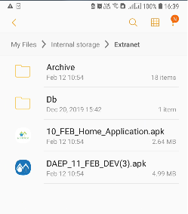
- Tap Click on DAEP App build apk file to start the installation process.

- Click on Install button.

- Click on Done button.
Launching the App:
- On the home screen find the Extranet Icon. Tap click on Extranet to launch the app.
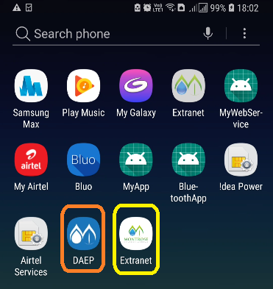
- Refer Extranet Android App User Manual for – How to use the App?

